**WEEK-2**

**MODULE -3**

**PL/SQL PROGRAMMING**

**SUPERSET ID:6407550**

**Exercise:4-Functions**

--Insert an account with specific balance for test

INSERT INTO Accounts (AccountID, CustomerID, AccountType, Balance, LastModified)

VALUES (30, 3, 'Savings', 5000, SYSDATE);

COMMIT;

**Scenario:1**

CREATE OR REPLACE FUNCTION CalculateAge(p_DOB IN DATE)

RETURN NUMBER IS

v_Age NUMBER;

BEGIN

v_Age := FLOOR(MONTHS_BETWEEN(SYSDATE, p_DOB) / 12);

RETURN v_Age;

END;

/

**OUTPUT:**

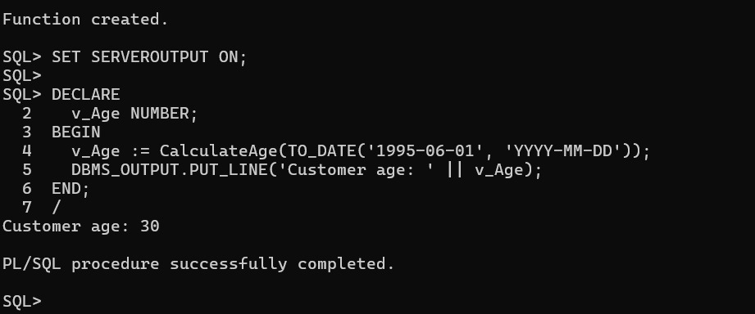

**Scenario:2**

CREATE OR REPLACE FUNCTION CalculateMonthlyInstallment(

p_LoanAmount IN NUMBER,

p_InterestRate IN NUMBER,

p_Years IN NUMBER

) RETURN NUMBER IS

r NUMBER := p_InterestRate / 12 / 100;

n NUMBER := p_Years * 12;

EMI NUMBER;

BEGIN

IF r = 0 THEN

EMI := p_LoanAmount / n;

ELSE

EMI := p_LoanAmount * r * POWER(1 + r, n) / (POWER(1 + r, n) - 1);

END IF;

RETURN ROUND(EMI, 2);

END;

/

**OUTPUT:**

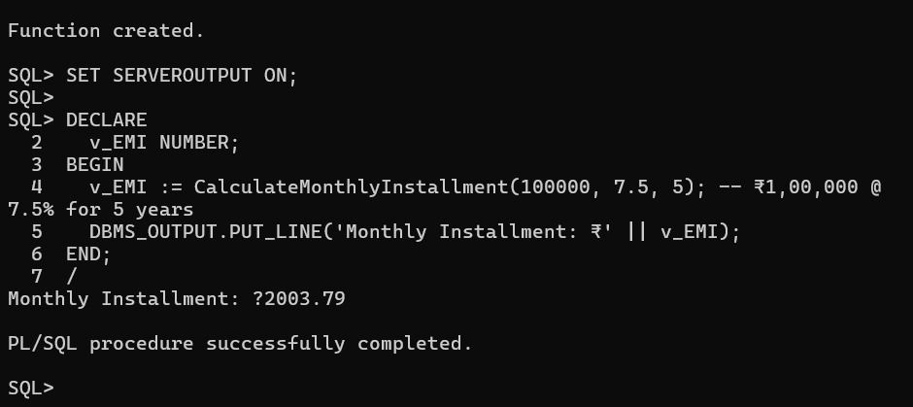

**Scenario:3**

CREATE OR REPLACE FUNCTION HasSufficientBalance(

p_AccountID IN NUMBER,

p_Amount IN NUMBER

) RETURN BOOLEAN IS

v_Balance NUMBER;

BEGIN

SELECT Balance INTO v_Balance FROM Accounts WHERE AccountID = p_AccountID;

RETURN v_Balance >= p_Amount;

EXCEPTION

WHEN NO_DATA_FOUND THEN

RETURN FALSE;

END;

**/**

**OUTPUT:**

